Computer–Based Spanish Learning Program

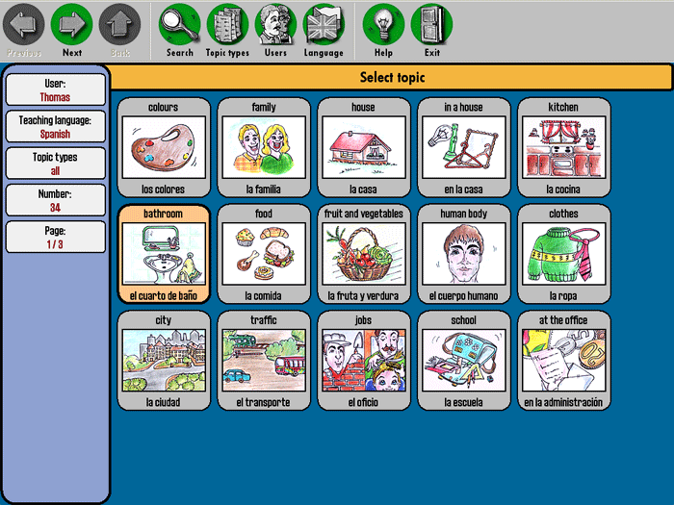
Background
As a computer science major taking a course in education I feel that while the experts continue to debate how much and when computers can best be used in the classroom, if at all, most experts agree that an education in the 21st century, the “Age of Information,” must go beyond just teaching students the three R’s. Computers are reshaping the way people live their lives today in profound and sometimes unexpected ways, and teachers are struggling to find appropriate ways to use this technology in the classroom. In addition to learning about computers it is also becoming increasingly important to learn how to speak Spanish in today’s society (Perelman, 2006).
As Americans whether we like it or not immigrants are changing the face of America. Hispanics constituted 16 percent of the nation’s total population and 26 percent of the U.S. population speaks Spanish. This number is expected to grow over the next ten years. Due to the increase in the Spanish speaking population it has become a great asset to many companies if their employees speak both English and Spanish.
The U.S. Census Bureau reports that the number of foreign-born persons in the United States surged to 28 million in 2004 and now represents 12 percent of the total population, the highest figures in a century. (Fernandez-Kelly, 2006) In New York City, 54 percent of the population is of foreign stock--that is, immigrants and children of immigrants. Of all the immigrants how are immigrating into the United States most of them are Hispanic. In fact by as of 2000 Hispanics have replace black people as the largest minority group in the United States.

“aprendizaje español”
Based on what I know of the importance in knowing how to use computers and also learning how to speak Spanish in our society, the following proposal is for an instructional design document that will be used to construct a program that teaches elementary school children how to speak Spanish. This educational program will be titled “aprendizaje español” in English this translates into “Learning Spanish”. Elementary students who have “aprendizaje español” in their schools will have a huge head start in being able to learn a second language, thus they will have a huge head start in the job market when they get older.

Program Context

The context of “aprendizaje español” will consist of a 4 DVD set. This set introduces Spanish in a way kids will truly enjoy. The context will Star native Spanish speakers and 3-D animated characters, this DVD package will teach basic conversational Spanish within the context friendly and lively Spanish cartoon characters. Of these characters the stars will be Carlos and his cute Chihuahua puppy, " Ballyhoo". These colorful Spanish characters will teach useful phrases for everyday situations along with words for colors, numbers, playing and toys. The set will contain 20 lessons in total (5 complete lessons per DVD) on everyday words and conversation. It will include interactive DVD exercises that test lesson comprehension. It will introduce more than 350 practical phrases and vocabulary words. It will also have original songs that will also reinforce new words and phrases. The DVD set will also be accompanied with learning booklet so parents can review lessons with their child.

Identify Knowledge/Skill Gap
Actual Performance

The actual performance from students using “aprendizaje español” will be a positive one. Children advance much faster if they are using this program in a classroom setting. They have the guidance from an instructor, they are exposed to more visuals and there are an incredible variety of games to rehearse what they are learning. However, children can learn from the individual program without classes. Music plays an essential role in introducing vocabulary. The DVDS and the book are a wonderful aid to rehearse pronunciation of words, songs and phrases.

Desired Performance

The desired performance from use of “aprendizaje español” is an increase Spanish vocabulary. The focus is on the acquisition of vocabulary and practical conversation in the Spanish Language using a Spanish Tone.

Terminal Objectives
At the end of the first DVD students will know and be able to complete tests at the end of each section with 75% accuracy.
- 5 songs
- Pronunciation - Alphabet, Spanish vowel and consonant sounds, reading skills.
- Colors - 12 colors
Greetings - phrases
- Numbers - 1-100
- Questions - 10 questions in Spanish
- Masculine and Feminine Concept
- Body - 20 vocabulary words
- Directions - 10 vocabulary words
- Verbs - 20 vocabulary words
- Personal Pronouns
- Cognates - 36 words that are similar in Spanish/English
At the end of the second DVD students will know and be able to complete tests at the end of each section with 80% accuracy.

- Continue review of the first DVD
- 5 more songs
- Conjugations (yo, tú, él, ella usted - simple sentences in the present/past/future)
- Family - 10 vocabulary words
- Opposites - 20 vocabulary words
- Days of the Week - 7 vocabulary words
- Months, Seasons/ Weather - 16 vocabulary words and weather expressions
- School - 20 vocabulary words
- Food - 20 vocabulary words
- Cognates - 30 words that are similar in Spanish/English

Enabling Objectives
At the end of the third DVD students will know and be able to complete tests at the end of each section with 80% accuracy.
- Continue review of DVD I & II
- 3 more songs
- Conjugations (yo, tú, él, ella usted, nosotros, ellos, ellas, ustedes - simple sentences in the present/past/future)
- Farm Animals - 25 vocabulary words
- House - 25 vocabulary words
- Clothing - 25 vocabulary words
- Time - Learn how to say the time in Spanish
- Cognates - 35 words that are similar in Spanish/English
At the end of the fourth DVD students will know and be able to complete tests at the end of each section with 85% accuracy.

- Continue review of DVD I, II & III
- 3 more songs
- Conjugations (yo, tú, él, ella usted, nosotros, ellos, ellas, ustedes - more complex sentences in the present/past/future)
- Wild Animals - 25 vocabulary words
- Places- 25 vocabulary words
- Occupations - 25 vocabulary words
- Ser/ Estar/ Tener - understand uses of ser, estar and tener
- Cognates – 3 5words that are similar in Spanish/English

Content and Tasks
Children are naturally more "efficient" foreign language learners and have a great capacity to learn a second language. “aprendizaje español” is based on the idea that this learning can be significantly enhanced through the use of: Music, Creative Visual Aids such as Carlos and his cute Chihuahua puppy, " Ballyhoo", games, variety in presentation and a relaxed and fun-filled environment. This program will contain 4 DVDS each DVD will contain 5 complete lessons and at the end of each lesson there will be an exam to measure the students progress.

Target Audience
The target audience of aprendizaje español will be 2nd to 6th grade elementary school students whose ages will range from 7 to 12 years of age. The program will also target the teachers and parents of these students so they assist in the learning process. We feel that in order for the program to be most effective students should start early. We also feel that a classroom could us two of the four disks per school year in order to thoroughly review its contents.

Technological Considerations

While there will be learning books to go along with this program the main source needed is a computer with a DVD drive, speakers, and a color monitor. There will be four DVDS to go along with this program that students, teachers and parents can easily use.

Summary/Conclusion
During the past decade there has been an increaingly high level of imporantance to learn how to use computers and to learn how to speak Spanish.
Sources
Fernandez-kelly, Patricia Out of the Shadows: Political Action And the Informal Economy in Latin America, ennsylvania State University Press, 2006

Perelman, L. J. School's out: Hyperlearning, the new technology, and the end of education. New York: William Morrow. 2008

